BOOK DEDICATION

One of the main priorities of our media center is to build a wonderful collection of books and materials that will benefit Lakewood students for years to come. We do this by purchasing library-bound books based on curriculum needs and student interest. You can help build our collection by dedicating a library book for your child.

If you would like to dedicate a book to your child, please, complete the following and return it to the media center with $15.00. We will take your child's photograph and place it on a label in the book with the following inscription:

"This book is dedicated to the Lakewood Media Center in honor of ________________ (student's name) by _______________ (donor's name)."

Print this form and return to Mrs. Booth in the Media Center.
Thank you for your support!

Example:
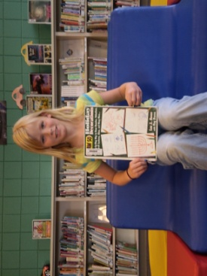
(Child’s name)
2012-2013
2nd Grade
This book is dedicated to (child’s name) by her mama and daddy.

